**FIRST NORMAL FORM**

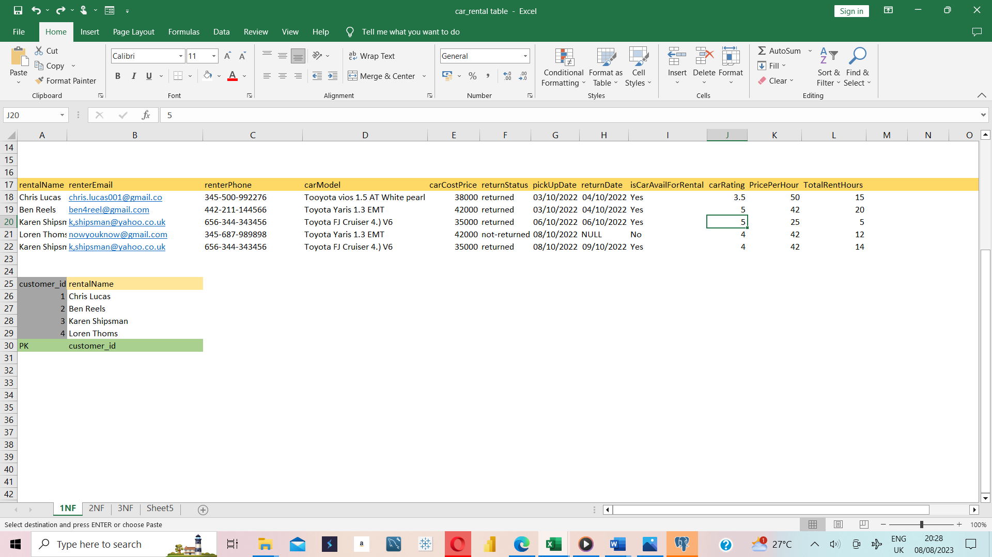

Figure 1: First normal Normalisation.

**SECOND NORMAL FORM**

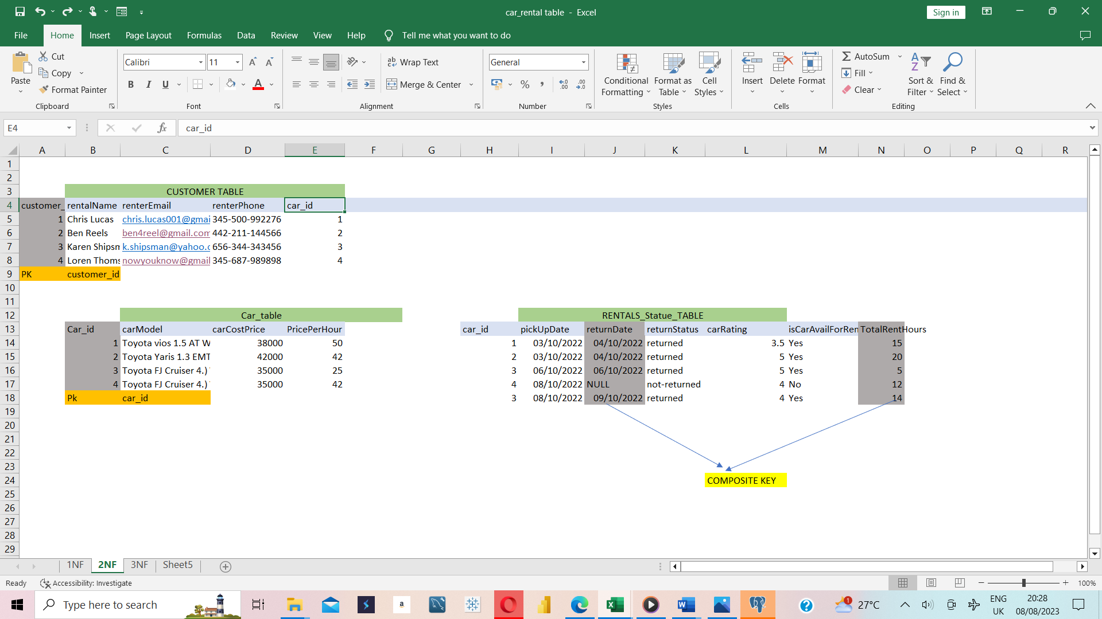

Figure 2: Second normal Normalisation.

**THIRD NORMAL FORM**



Figure 3: Third normal Normalisation.